Welcome to the Amsterdam Livingroom

HÖR, Sennheiser and Neumann expand their partnership with four days of live streams, DJ sets, workshops, panel talks and immersive audio experiences at ADE 2026

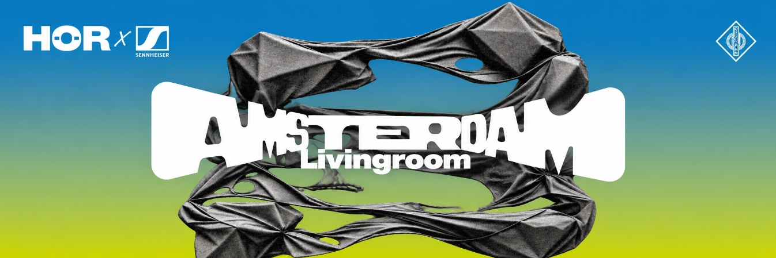

Wedemark/Amsterdam, 16 October 2026 – From 21 to 24 October 2026, Sennheiser, Neumann and Berlin-based music platform HÖR will transform independent shop, gallery and music studio Bonne Amsterdam into the Amsterdam Livingroom, a multi-room cultural hub connecting electronic music, community and professional audio technology at Amsterdam Dance Event 2026.
Following HÖR and Sennheiser’s partnership at last year’s ADE, the activation will feature four days of public programming, bringing together livestreams and DJ sets, panels, workshops, artist sessions and listening experiences, supported by iconic studio brand Neumann.
“With the Amsterdam Livingroom, we wanted to create a temporary home for audio and music culture during ADE. A place where artists, creators and audiences can experience professional audio not just as technology, but as part of the creative process,” says Itamar Marom, Brand Partnerships Manager at Sennheiser. “From listening sessions and workshops to live broadcasts and studio conversations, our aim is to make those experiences more accessible and relevant to the next generation.”
A key highlight will be the Neumann Sound Experience on 21 October. French electronic artist NTO will present his new album NAKED in a dedicated quadraphonic listening session, powered by Neumann’s newly launched KH 350 and KH 310 II studio monitors, before performing live for HÖR. The four-channel setup will invite visitors to experience the music beyond conventional stereo playback and demonstrate how precision monitoring can open up new creative and listening perspectives.

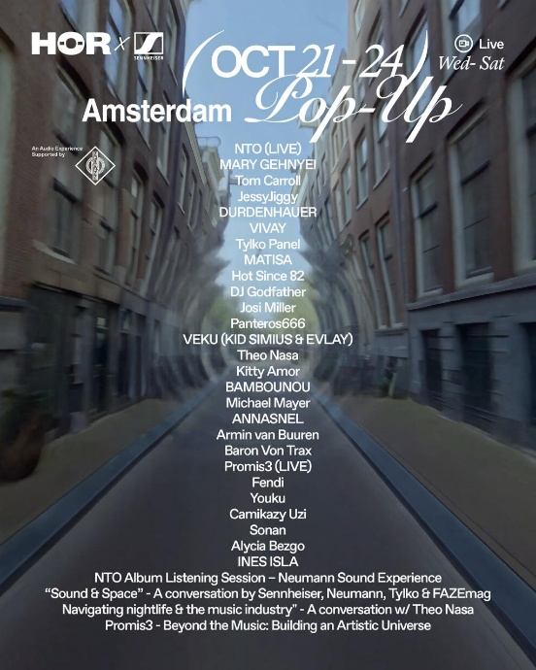

With the Amsterdam Livingroom, HÖR, Sennheiser and Neumann offer four days of live streams, DJ sets, workshops, panel talks and immersive audio experiences

The wider program reflects the breadth of the Amsterdam Livingroom. On 22 October, “Sound & Space” will bring together contributors from Sennheiser, Neumann, Tylko and FAZEmag for a conversation about the relationship between sound and physical environments, followed by live sets from artists including MATISA, Hot Since 82 and DJ Godfather. On 24 October, Promis3 will explore the creative world beyond music in the session “Beyond the Music: Building an Artistic Universe,” followed by a live performance and further HÖR sets.
Across the Amsterdam Livingroom, Sennheiser and Neumann technology will support livestreams, discussions, recording workflows and listening experiences. Embedded throughout the creative program, the technology will help artists share their work and enable audiences to experience it as intended, while a dedicated recording studio will be available for product demonstrations, artist sessions and conversations with the Sennheiser and Neumann teams.
The Amsterdam Livingroom takes place at Bonne Amsterdam, Warmoesstraat 67, from 21 to 24 October 2026. Entry to the live DJ sets, panels, listening experiences and workshops is free, subject to capacity. The full program as well as an RSVP option are available here.

About the Sennheiser Group
Building the future of audio and creating unique sound experiences for our customers - this is the aspiration that unites the employees of the Sennheiser Group worldwide. The independent family-owned company Sennheiser was founded in 1945. Today, it is managed in the third generation by Dr Andreas Sennheiser, and is one of the leading manufacturers in the field of professional audio technology.

Press contact
Jacqueline Gusmag
Global PR & Influencer Manager
+49 5130 600 1540
jacqueline.gusmag@sennheiser.com

